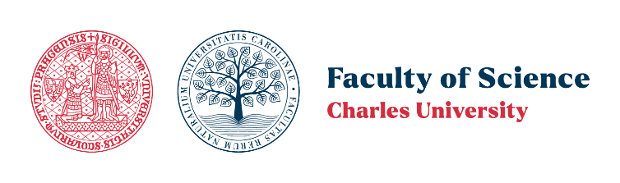
Applicants for postdoctoral fellowships (landslides, natural hazards) wanted at Charles University in Prague, Czechia, through the MSCA & CHARLESTON programmes

We are looking for truly outstanding candidates who are willing to develop and submit their own research project (with support from the prospective supervisor - Dr. Gianvito Scaringi) on the following topics:

Topic 1. Landslides in a changing climate
The ideal candidate has a project proposal to explore the role of climate change on landslides (and, more broadly, natural hazards) in study areas of their choice (where data are available to them) by means of either physically-based modelling or physics-informed data-driven approaches at various scales: from individual slopes to catchments and entire orogens. The candidate should bring a fresh, original perspective rather than proposing applications or incremental refinements of existing methodologies. Our interest lies primarily in thermal effects, but ideas are welcome for accounting for diverse coupled processes into the picture (hydro-mechanical, thermo-hydro-mechanical, chemo-mechanical processes, etc.). Also, multidisciplinary studies are encouraged, where societal aspects are also considered so as to quantify risk (not only susceptibility and hazard) and propose risk reduction strategies.

Topic 2. Chemo-mechanics of clay landslides and engineered clay barriers
The ideal candidate plans experimental campaigns and/or constitutive modelling of clay soils accounting for chemo-hydro-mechanical coupling. We are especially interested in how the exposure of clays to salt solutions, acids and bases, and organic compounds can temporarily or permanently alter the hydraulic and mechanical behaviours of clay soils, with possible applications in slope stability/landslide stabilisation and/or engineered clay barriers. The candidate should propose their own original experimentation or a novel modelling strategy. It is not a must, but it is desirable for the candidate to have the skills to explore the full thermo-chemo-hydro-mechanically coupled response of soils.

The candidate must hold (or expect to obtain shortly) a PhD degree in engineering geology, geotechnical engineering, or geosciences with a thesis clearly matching one of the topics above.
Candidates who have obtained their degree more than 8 years before the call deadline or have lived in the Czech Republic for over 1 year in the past 3 years are not eligible to apply.

Please note that we are looking for candidates who will apply for a postdoctoral fellowship under either the EU MSCA PF programme (https://ec.cuni.cz/ECEN-128.html) or the Charles University "CHARLESTON" programme (https://cuni.cz/UKEN-2187.html). The success of the application is obviously not guaranteed. We offer support in preparing a competitive proposal that harmonises the needs and skills of the candidate, the supervisor, and the hosting department.

We will only consider outstanding candidates with clear potential and a documented publication record stemming from their doctoral/postdoctoral research.

To be considered, applications must be received by 15 April 2025. The selected candidate(s) will then work with the supervisor on the preparation of the project proposal, with support from Charles University.

Please submit your resume, motivation letter, and a pitch for a project proposal (max 2 A4 pages including up to 1 figure and references) to gianvito.scaringi@natur.cuni.cz. Incomplete applications will be discarded.

